**Raytracer Service**

**User Manual**

**Kaihua Zhou 999482983**

**Ya Han Yang 1004550700**

Introduction

Our website, the Raytracer Service, mainly has four different features: account creation, 3D object image creation, image publishing and deletion. This document provides instructions on how to use each of these features.

1. Account Creation

You will be able to register, log in and log out. You can simply click on the buttons on the index page to register or login, your will be redirected to the corresponding form page.

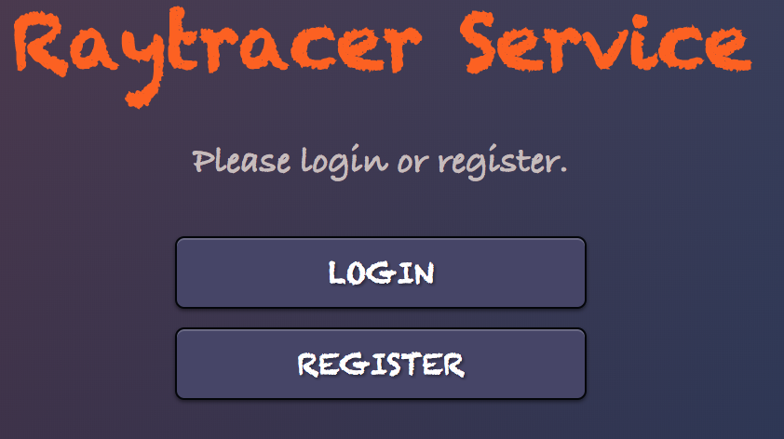

* 1. Register

On the register page, fill in the your information and click the ‘GO Register’ button. Please note that your password should contain at least four characters.

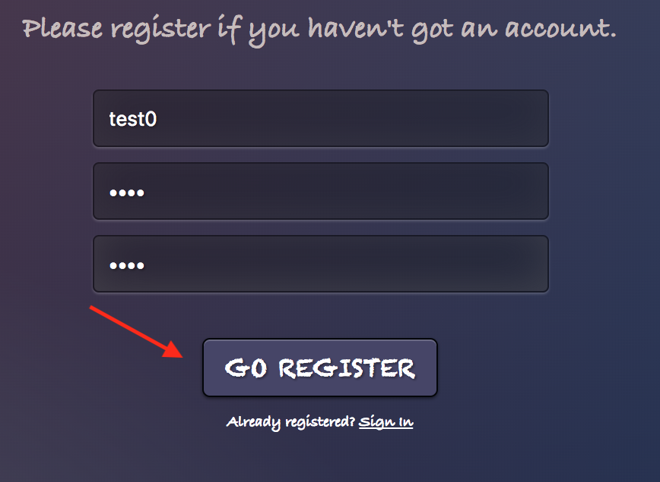

If successfully registered, you will be automatically logged in and redirected to your dashboard page. In case if your entered username is already registered or your passwords don’t match, you will see an error message above the form. You can also go to the sign in form by clicking on the Sign in link.

* 1. Log In

To login, fill out the login form and click on ‘LET ME IN’. You will be redirected to the dashboard page if successfully logged in. Otherwise, you will see error message above the form. You can also go to the register form by clicking on the Register link.

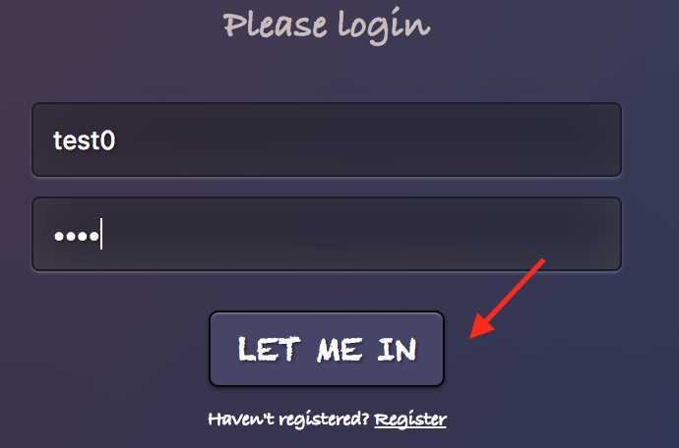

* 1. Log Out

Once you have successfully signed in, you will see your dashboard page with a navigation menu on top. To logout, you have to click on the ‘LOGOUT’ button in the navigation menu, then you will be redirected to the index page.

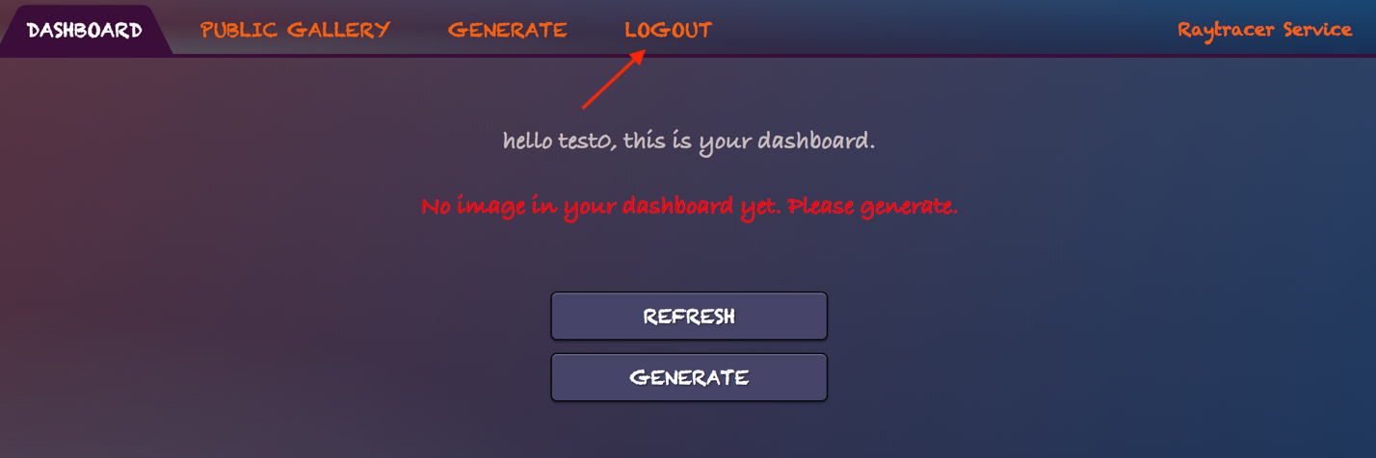

1. 3D Object Image Creation

To create an image, you can either click on the ‘GENERATE’ button on your dashboard or on the navigation menu. Once you have clicked on it, you would be redirected to the image rendering form.

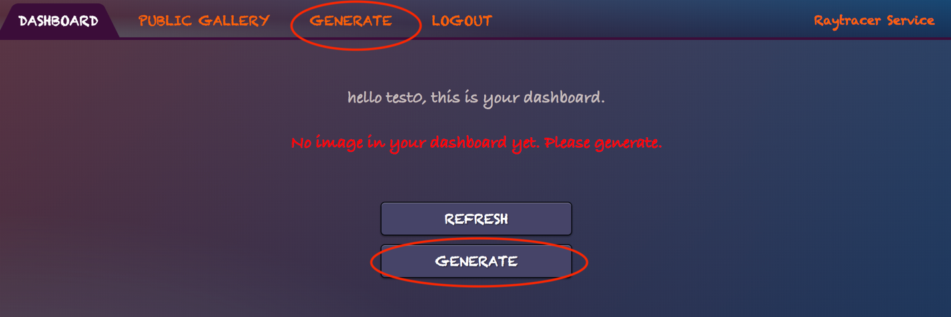

* 1. Image Rendering

On the image rendering form, you will first see three number inputs which stands for the number of rectangles, spheres and triangles you want to add in your image. You can use the ‘+’ and ‘-’ buttons to modify these numbers and the maximum number of each object is 5. Please set these numbers before you start filling in the form, otherwise you may lose input information. Number of object information forms depends on these numbers.

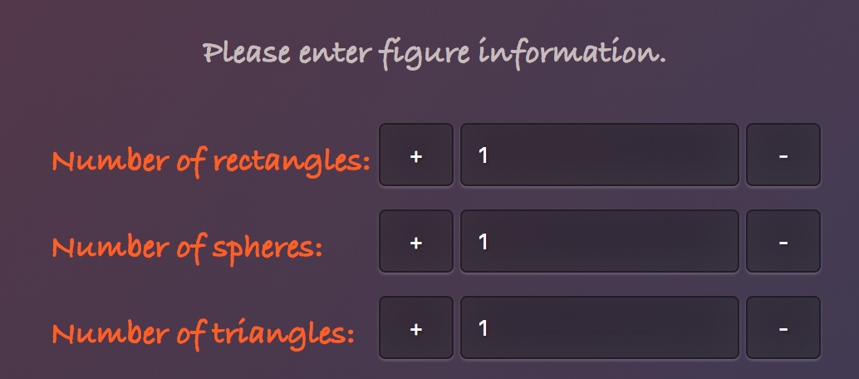

You will also be able to choose the image size (width: 400-800px, height: 300-600px), camera position and center (camera defines from which points the objects will be observed), and light position (from where light will be shine down on the objects).

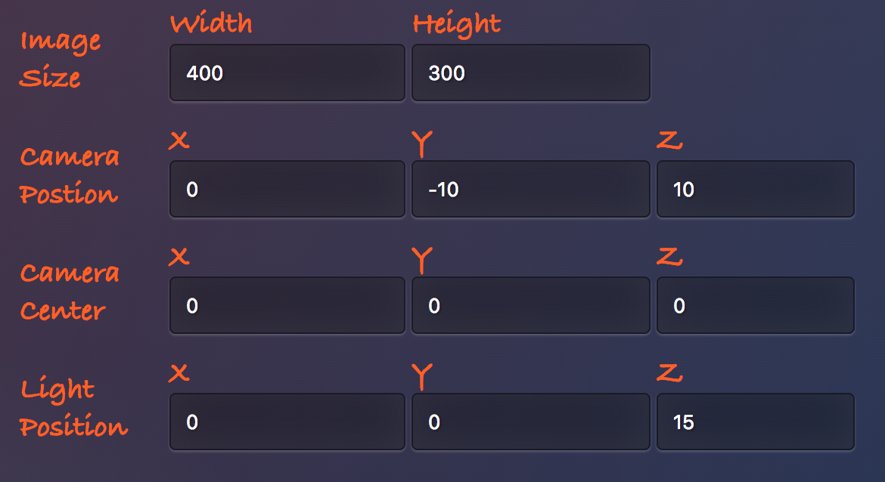

Last but not least, you will able to enter object coordinates, color and reflectivity. Reflectivity is between the range 0.1 to 1. The example below is for two spheres one beside another, the first one will be green and 80% reflectivity and the second one will be blue and 0% reflectivity.

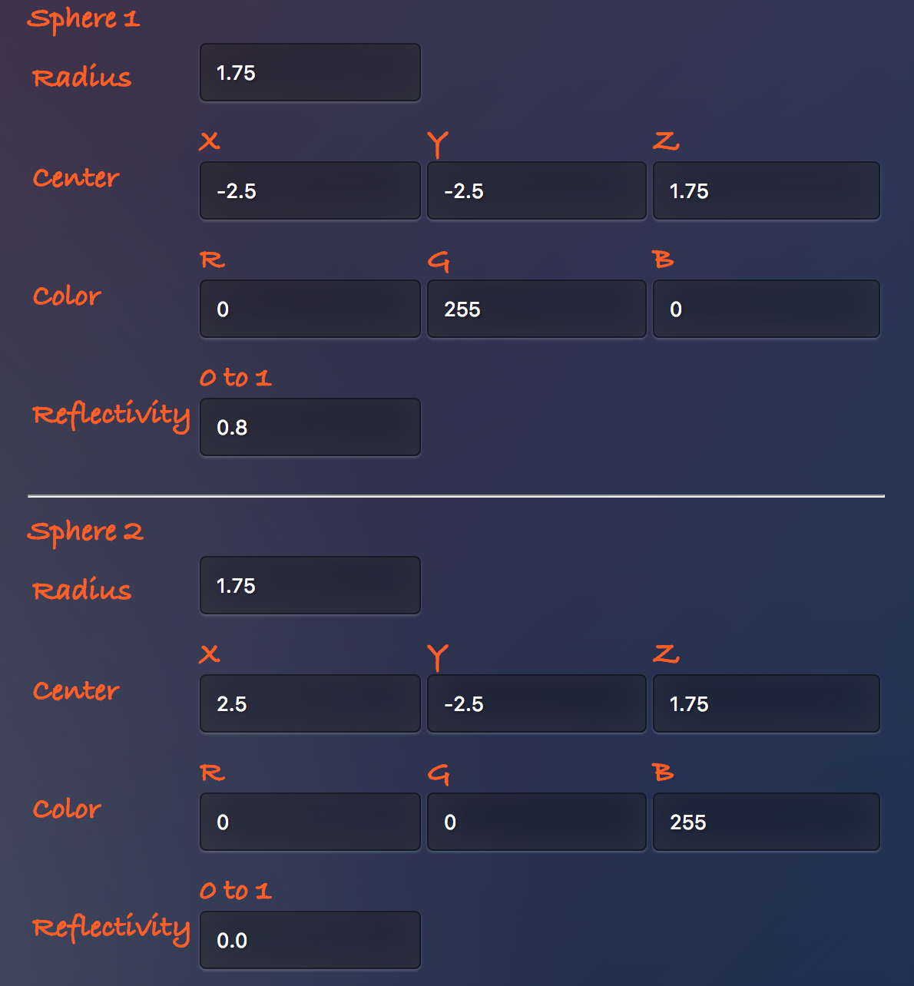

All input boxes require input. In case you might not know what to fill in for some input boxes, we’ve already set up default values except for the object coordinates.

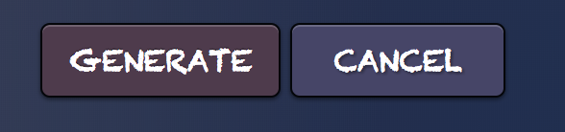

Finally, you can click on the ‘GENERATE’ button to generate the image. You will be alerted If you missed some inputs. You will see an error message if the number of objects is 0.

* 1. Image Viewing

Once you have click on the ‘GENERATE’ button, you will be redirected to dashboard if your inputs are correct, and you will see a new loading thumbnail. This thumbnail implies the system is currently generating your image, you might want to click on the ‘REFRESH’ button to refresh the page and see whether the image is done.

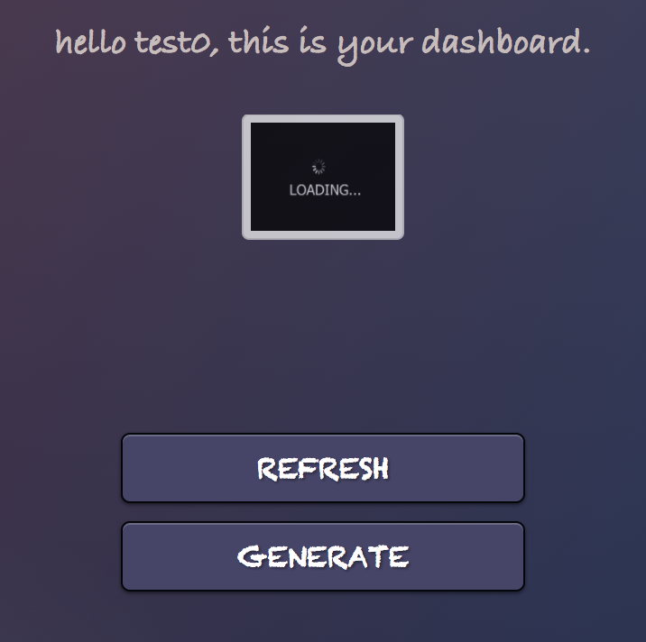

If you click on the loading thumbnail, a message saying ‘We are still generating the image’ will pop up. You can choose to refresh the page, or to delete the image if you find it taking too long to generate.

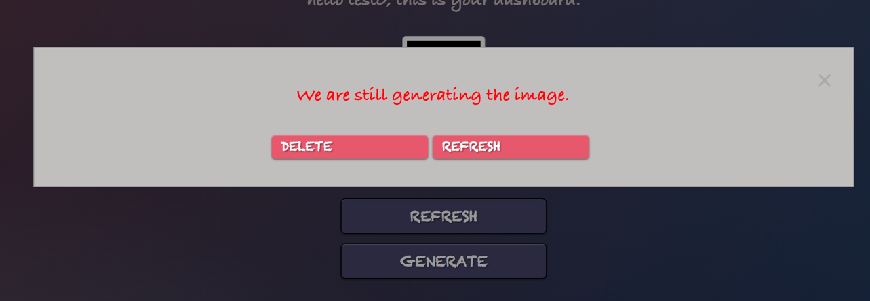

Once the image is fully rendered, you will see the image as thumbnail on your dashboard. You can click on the thumbnail to be redirected to the image page.

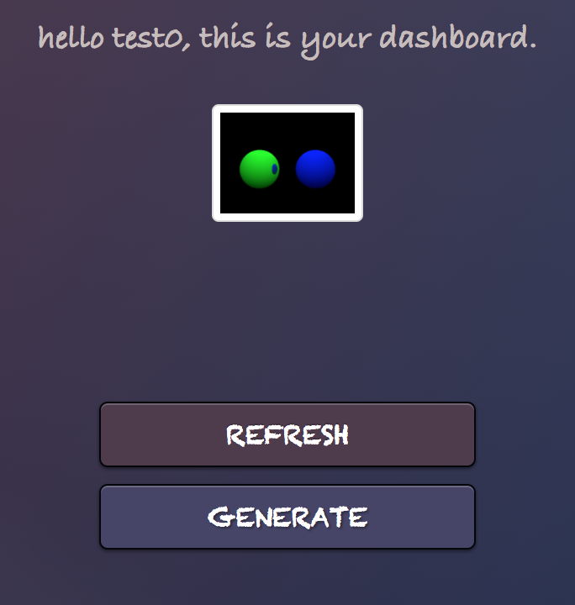

The image page will show you the time stamp (image creation time), status of the image rendering process, ownership, object information and the image itself. You can publish, download or delete the image from this page.

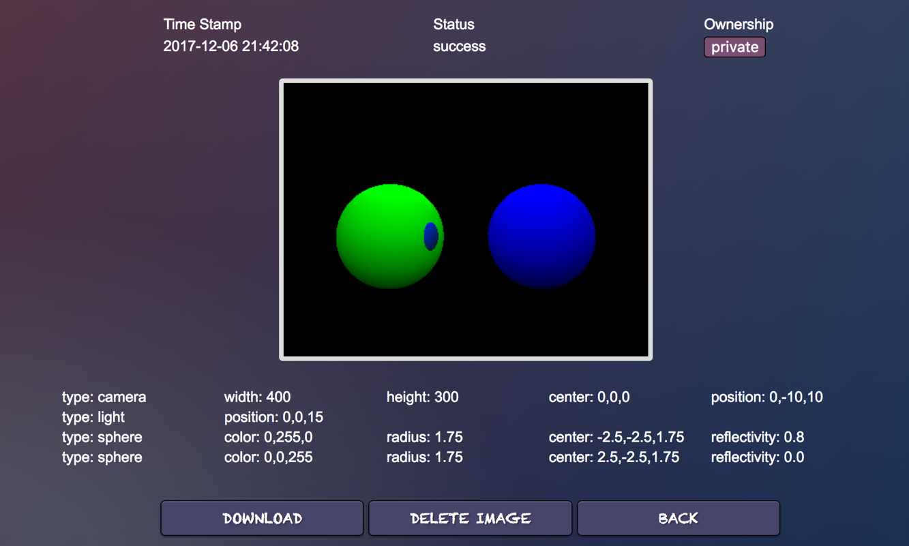

1. Image Publishing

Our application supports image publishing. It allows you to see public images from other users, or publishing your own images to others.

* 1. Public Gallery

To access the public gallery, simply click on the ‘PUBLIC GALLERY’ on the navigation menu. From here you can view public images from other users.

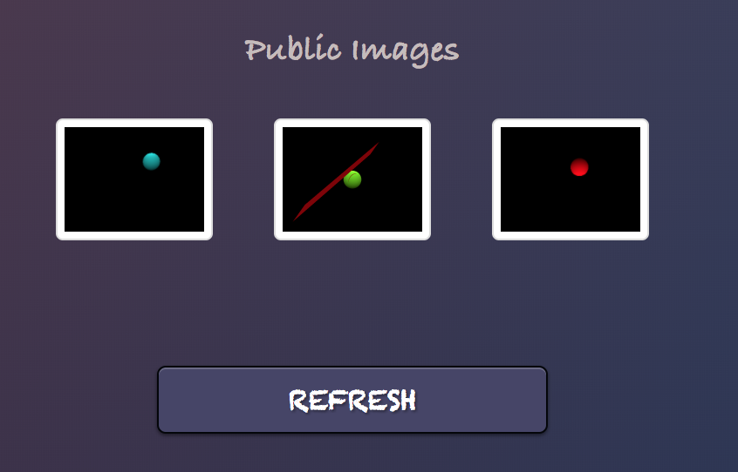

Clicking on an image thumbnail will allows you to be redirected to the image page with details of the image including timestamp, status, owner, object information and the image itself. Please note that you are not allowed to do any modification on other’s public images.

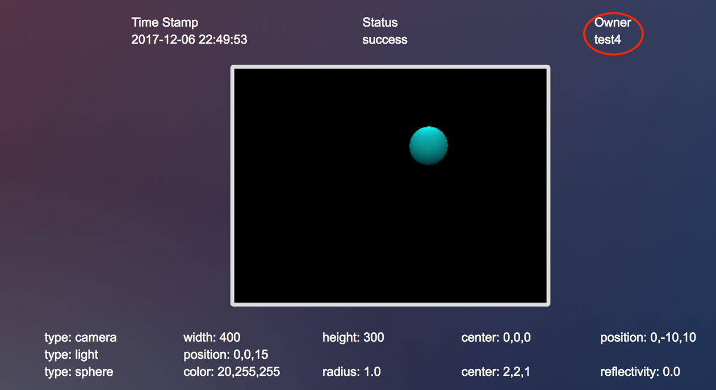

* 1. Publishing your image

Your images are set to private as default during the rendering process. If you want to publish one of your images, you need to go to that image page from your dashboard and click on the ownership button (‘private’).

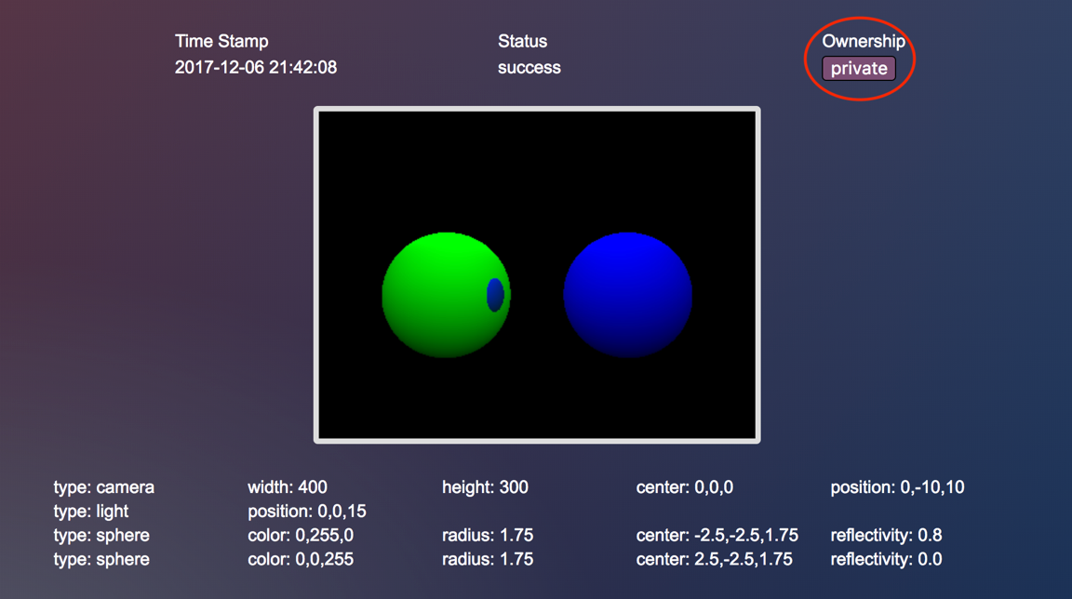

Once you’ve clicked on it, the image page will refresh and shows you the new ownership of the image.

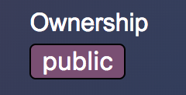

Now you can see your image in the public gallery page

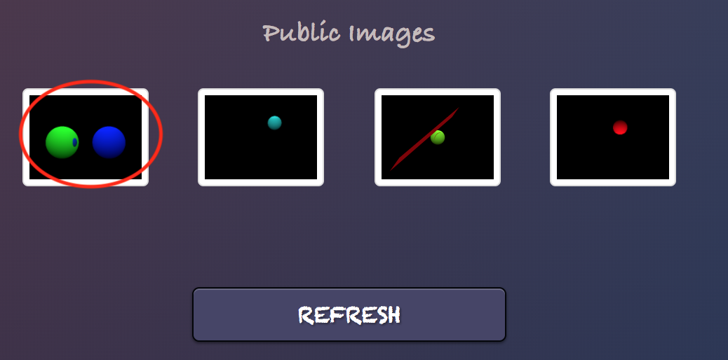

Clicking on the thumbnail of your image from public gallery will show you the same information as the image page redirected from your dashboard. You will be able to do modification on the image. To revert the ownership, simply click on the ownership again and your image will disappear from the public gallery.

1. Image Deletion

To delete an image, navigate to the image page and click on the ‘DELETE’ button. This button is only available if the image belongs to you.

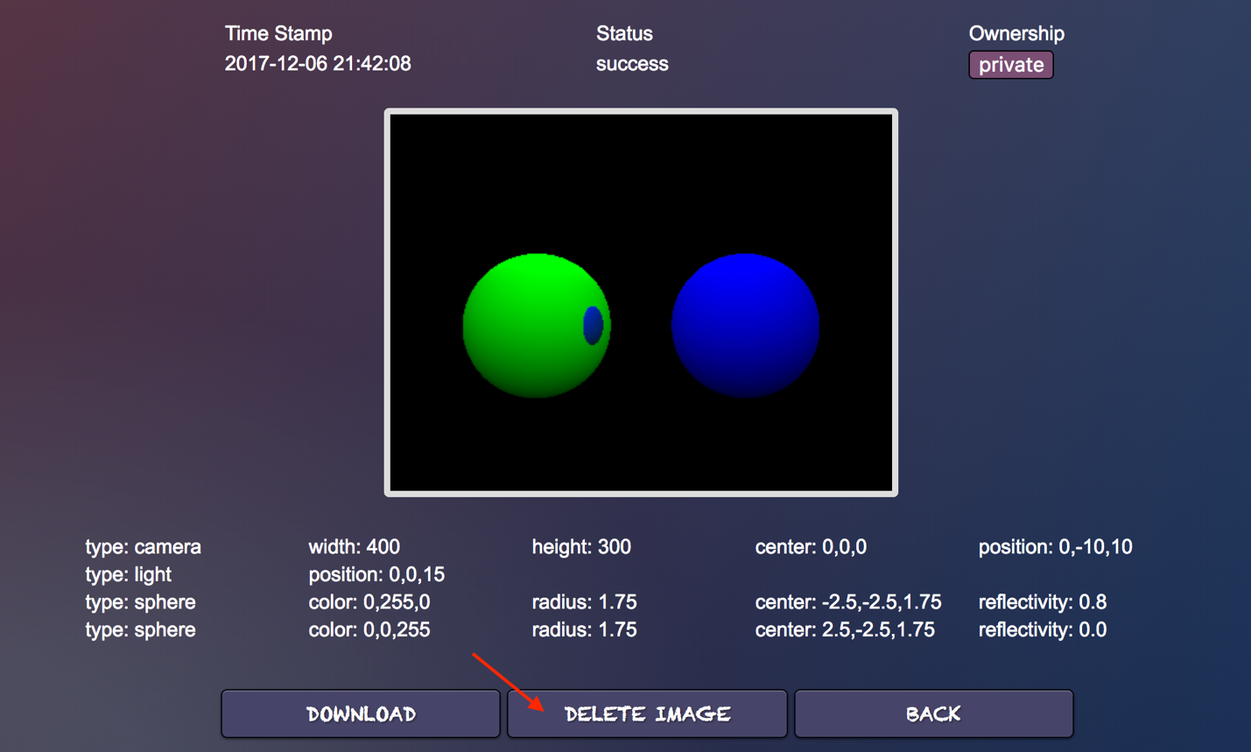

The image will be removed from your dashboard, and the public gallery if it was public.